**Management :Project Report**

**Company: Reliance Petroleum Ltd.**

**Group 3:- Project Members:**

Arundhati Das

Arushi Sehgal

Kanika Sharma

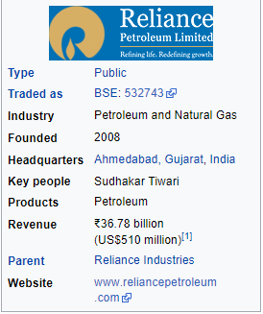

**Reliance Petroleum Limited** is a company owned by [Reliance Industries Limited](https://en.wikipedia.org/wiki/Reliance_Industries_Limited) (RIL), one of India's largest private sector companies. It is based in [Ahmedabad](https://en.wikipedia.org/wiki/Ahmedabad), [Gujarat](https://en.wikipedia.org/wiki/Gujarat), [India](https://en.wikipedia.org/wiki/India) and has interests in the [downstream oil](https://en.wikipedia.org/wiki/Downstream_(oil_industry)) business. RPL also benefits from a strategic alliance with Chevron India Holdings Private Limited ([Singapore](https://en.wikipedia.org/wiki/Singapore)), a wholly owned subsidiary of [Chevron Corporation](https://en.wikipedia.org/wiki/Chevron_Corporation) USA (Chevron), which currently holds a 5% equity stake in the Company.

Reliance Petroleum and RIL own / have long term chartered two [oil rigs](https://en.wikipedia.org/wiki/Oil_rigs) - DD KG-1 and DD KG-2 (DD standing for Dhirubhai Deepwater). They are both [drilling ships](https://en.wikipedia.org/wiki/Drillship) registered in [Marshall Islands](https://en.wikipedia.org/wiki/Marshall_Islands) and owned by Deepwater Pacific Inc., a subsidiary of [Transocean](https://en.wikipedia.org/wiki/Transocean). This group's activities span exploration & production of oil & gas, petroleum refining and marketing, petrochemicals (polyester, fibre intermediates, polymers and chemicals.The company's [petrochemical](https://en.wikipedia.org/wiki/Petrochemical), [refining](https://en.wikipedia.org/wiki/Refining), oil and gas-related operations form the core of its business.

On 18 October 2007, Reliance Industries became the first Indian company to breach $100 billion market capitalization. The company is ranked **148**th on the [Fortune Global 500](https://en.wikipedia.org/wiki/Fortune_Global_500) list of the world's biggest corporations as of 2018. It is ranked 8th among the Top 250 Global Energy Companies by [Platts](https://en.wikipedia.org/wiki/Platts" \o "Platts) as of 2016. Reliance continues to be India’s largest exporter, accounting for 8% of India's total merchandise exports with a value of Rs 147,755 crore and access to markets in 108 countries. Reliance is responsible for almost 5% of the government of India's total revenues from customs and excise duty. It is also the highest income tax payer in the private sector in India. The company's equity shares are listed on the [National Stock Exchange of India](https://en.wikipedia.org/wiki/National_Stock_Exchange_of_India) Limited (NSE) and the [BSE](https://en.wikipedia.org/wiki/Bombay_Stock_Exchange) Limited.

**Promoter of Reliance**

Mukesh Ambani ,Nita Ambani,Isha M Ambani,Anant M Ambani,Akash M Ambani ,Devarshi Commercials LLP, Karuna Commercials LLP, Srichakra Commercials LLP, Svar Enterprises LLP, Vasuprada Enterprises LLP, Shreeji Comtrade LLP, and Shrikrishna Tradecom LLP. 

**Products of Reliance Petroleum**

* Petroleum.
* Natural gas.
* Petrochemicals.
* High-Speed Diesel
* Auto LPG & packed LPG
* Lubricants
* Aviation Fuel

**SWOT Analysis of Company:** 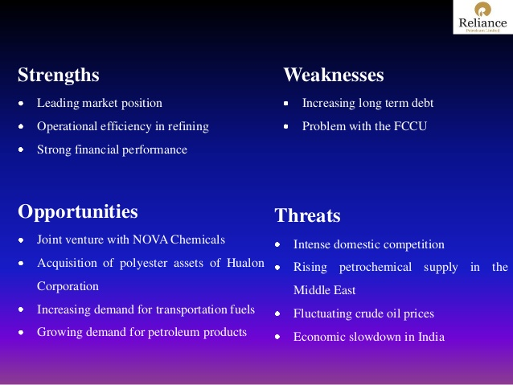

**Business process flow**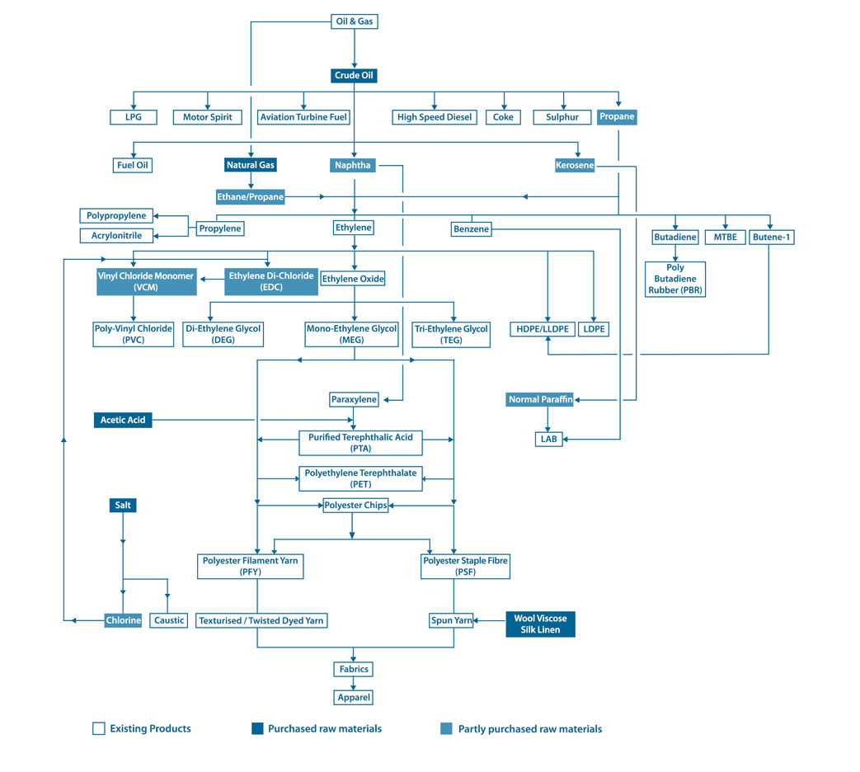

**Major RM used and price trends of Major Raw materials**

LPG,Naphtha,Gasoline,Sulphur,Propylene,High Speed Diesel,Alkylate

**PEST analysis**

**PEST stands for - Political, Economic, Social, Technological**

**Political factors:**

* Political stability and importance of Capital Goods sector in the country's economy.
* Level of corruption - especially levels of regulation in Capital Goods sector.
* Legal framework for contract enforcement
* Taxation - tax rates and incentives
* Wage legislation - minimum wage and overtime
* Anti-trust laws related to Capital Goods

**Economic factors:**

* Education level in the economy
* Labor costs and productivity in the economy
* Business cycle stage (e.g. prosperity, recession, recovery)
* Economic growth rate
* Discretionary income
* Unemployment rate
* Inflation rate
* Interest rates

**Social factors:**

* Demographics and skill level of the population
* Class structure, hierarchy and power structure in the society.
* Education level as well as education standard in the Reliance Worldwide Corporation Limited ’s industry
* Culture (gender roles, social conventions etc.)
* Attitudes (health, environmental consciousness, etc.)
* Leisure interests

**Technological factors:**

* Recent technological developments by Reliance Worldwide Corporation Limited competitors
* Technology's impact on product offering
* Impact on cost structure in Capital Goods industry
* Impact on value chain structure in Capital Goods sector
* Rate of technological diffusion

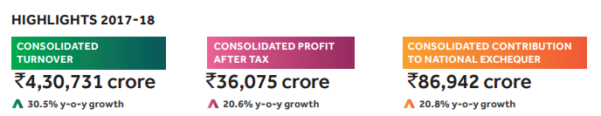

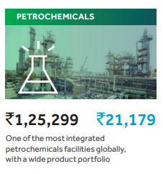

Petrochemicals FY 2017-18 saw stabilisation of the ethane import project and commissioning of the large projects at Jamnagar – refinery off-gas cracker, PX expansion, and other downstream capacities. These projects took refinery-petrochemicals integration to an unprecedented level globally. The commissioning of the Jamnagar projects, one of the world’s most complex set of projects, in significantly lessertime and lower cost than comparable projects worldwide, further endorsed RIL’s world-class project execution capability. The petrochemicals segment benefited from expanded capacities as various projects commenced operations through the year. The segment’s EBIT increased sharply by 63% to its highest ever ₹21,179 crore ($3.2 billion). Production increased 23.7% to 30.8 MMT. The EBIT margins increased sharply to a record level of 16.9% from 14.0% of last year, owing to favourable product deltas across the integrated polyester chain, PP and PVC. The refinery off-gas cracker and its downstream PE and MEG units were successfully stabilised in the last quarter of FY 2017-18. Our Petrochemicals business has progressed further on the expression of ‘Chemistry for Smiles’. We have created R|Elan™, a portfolio of specialty fabrics, a perfect blend of “art” and “smart” and launched eco-friendly products based on recycled PET bottles. Making life better for everyone.

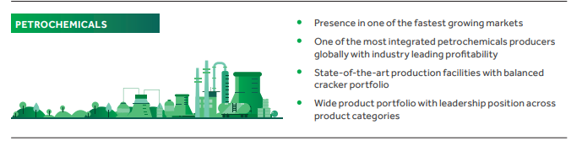

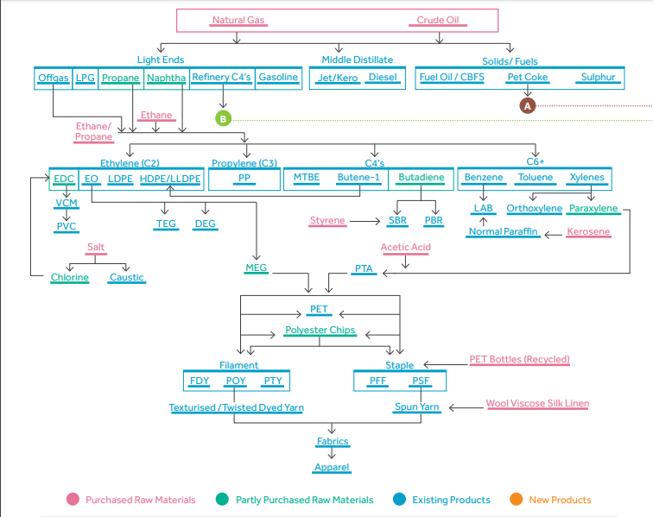

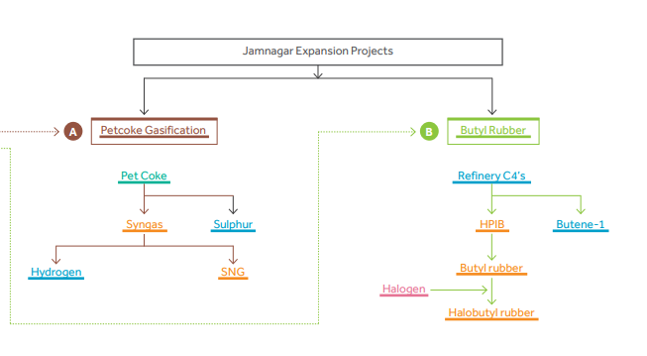

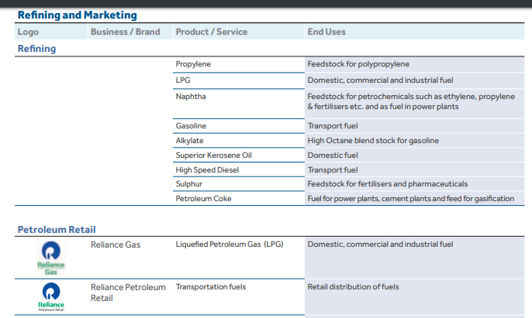

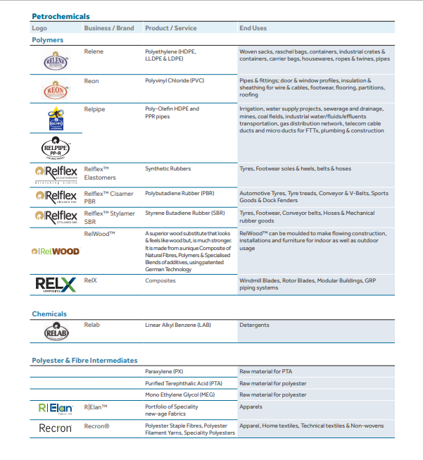

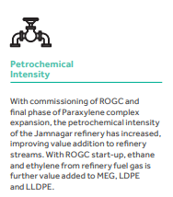

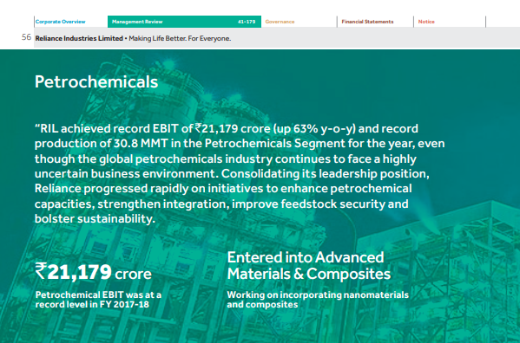

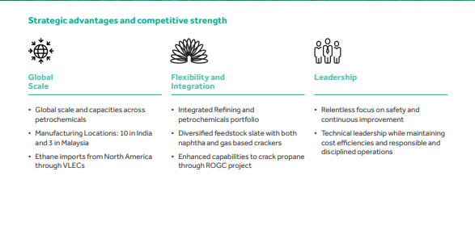

**Key success factors**

• **Outreach.** In collaboration with program partners, the Reliance center has been able to provide quality services not only to company employees but also to a wide range of people in the community and at local enterprises. Indeed, patients from across southern Gujarat visit the center, some from as far as Amreli and Junagarh. The company attributes the success of its outreach efforts to the quality of services provided by the center and the referral network set up by partners.

• **NGO partnerships.** Top managers at Reliance have contributed greatly to the program’s effectiveness through their involvement and commitment. But NGO partners have played a crucial role in enabling the program to expand and reach out to villagers, industrial workers, truckers, and the HIV-positive population.

**Key Industry Risk**

RIL's petrochemical operations are exposed to feedstock price and availability volatility. Additionally, inability to meet shifting demand for various petrochemical products could crimp returns. In exploration and production, RIL's difficulty in replacing used/depleted reserves in time could lead to reduced profitability. Low oil and gas prices could hurt cash flows and have a negative impact on margins. Prolonged periods of low energy prices would weaken returns on capital and hurt the economics of new oil and gas projects.

**PORTERS 5 FORCES ANALYSIS**

**THREAT OF NEW ENTRANTS**: There is thousands of oil and oil services companies throughout the world, but the barriers to enter this industry are enough to scare away all but the serious companies. Barriers can vary depending on the area of the market in which the company is situated′ Need Ample cash′ Need specialized worker

**POWER OF SUPPLIERS**:While there are plenty of oil companies in the world, much of the oil and gas business is dominated by a small handful of powerful companies.

**POWER OF BUYERS**: The balance of power is shifting toward buyers. Oil is a commodity and one companys oil or oil drilling services are not that much different from others. This leads buyers to seek lower prices and better contract terms

**AVAILABILITY OF SUBSTITUTES:**Substitutes for the oil industry in general include alternative fuels such as coal, gas, solar power, wind power, hydroelectricity and even nuclear energy.

**COMPETITIVE RIVALRY:** Slow industry growth rates and high exit barriers are a particularly troublesome situation facing by firms.′ At the same time, exit barriers in the refinery business are quite high.′ Besides the scrap value of the equipment, a refinery that does not operate has no value-adding capability.

# [Reliance Industries](https://craft.co/reliance-industries) competitors

Reliance Industries Competitors include Indian Oil, BPCL,HPCL, ONGC,Essar Oil

**Demand – Supply dynamics, Demand trends**

Market Environment FY 2017-18 witnessed strong recovery in global energy prices, which was mirrored in petrochemical feedstock and product prices. Healthy supply demand fundamentals bolstered petrochemicals operating environment and resulted in strong petrochemicals margins. Olefins and Polymers Global demand for ethylene increased by 5.5% y-o-y to 153 million tonne (MMT) in 2017. Global ethylene operating rates, which are indicative of the margin environment, were flat during 2017 but witnessed sustainable operation above the five-year average of 88%. Operating rates are expected to dip marginally in 2018 as new capacities in the US come online. Global Ethylene Supply/Demand 2017 Production by feedstock Demand by end use Production : 153 MMT Demand : 153 MMT Naphtha 41% Polyethylene 62% Ethane 38% Ethylene Oxide 15% Propane 9% Ethylene Di-Chloride 9% Butane 5% Ethyl Benzene 6% Others 7% Others 8%

The demand for propylene increased by 4.2 MMT in 2017 from the previous year, while supply gained approx. 4 MMT as compared to the previous year. Addition of 6-6.5 MMTA new global capacities in 2018 is expected to strengthen supply fundamentals in the near-term. Major capacity additions in Northeast Asia is from on-purpose units. With stringent environmental restrictions in China and rising crude and feedstock prices for Coal and Methanol to Olefins (CTO / MTO) and Propane DeHydrogenation (PDH), the operations of such units are expected to vary depending upon economic viability. On purpose propylene units are expected to remain marginal contributors to fulfill regional demand.

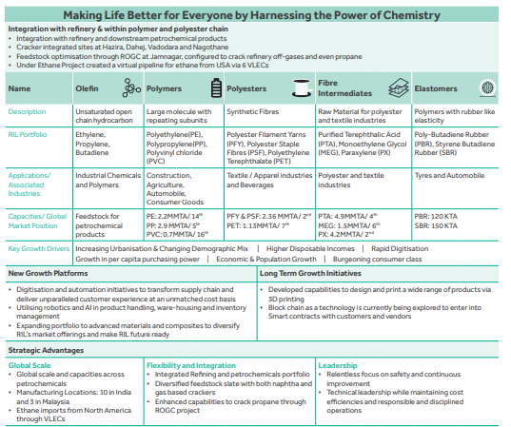

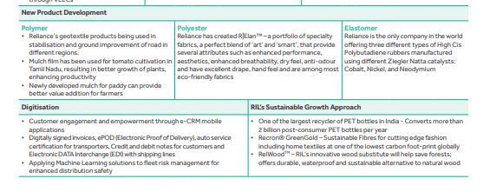

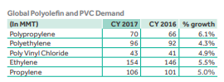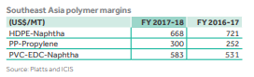

Firm ethylene prices supported positive trends in MEG markets, with prices touching the highest levels in 4 years. During CY 2017, net global capacity addition of 1 MMT was lower than demand growth of 1.4 MMT. During the year, Reliance commissioned its new MEG capacity in Jamnagar. The new capacity is running at optimum throughput and the additional volume has been absorbed in domestic and export markets

**Corporate Overview Management Review 41-179**

Governance Financial Statements Notice Financial and Operational Performance Financial Performance FY 2017-18 (` in crore) FY 2017-18 (US$in Billion) FY 2016-17 (` in crore) % Change Revenue 1,25,299 19.2 92,472 35.5 EBIT 21,179 3.2 12,990 63.0 EBIT (%) 16.9% 14.0% FY 2017-18 revenue from the Petrochemicals segment increased sharply by 35.5% y-o-y to `1,25,299 crore (US$19.2 billion). Revenue growth was primarily due to higher volumes from new Paraxylene, ROGC and its downstream units (PE and MEG), with the segment achieving its highest ever production level of 30.8 MMT, up 24% y-o-y. Petrochemicals segment EBIT increased sharply by 63.0% to its highest ever level of ` 21,179 crore (US$ 3.2 billion). RIL is the only producer of LDPE in India, and witnessed a surge in market share from 35% to 53% post commissioning of ROGC .

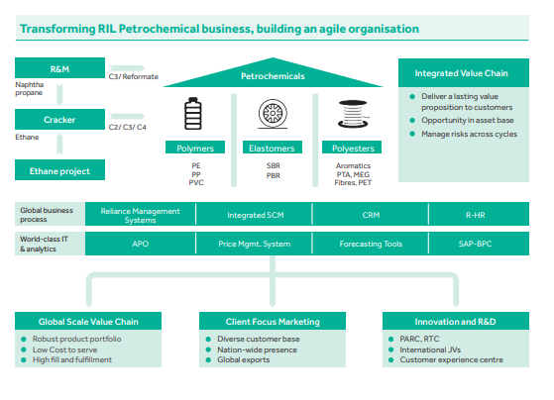

Circular Economy For Reliance, ‘Sustainability’ is not just a word but it is the ‘Way Reliance Operates”. RIL continues to focus on promoting ‘Circular Economy’ and delivering ‘Societal Value’. Through innovation and application of technology, RIL continue to create sustainable products. Petrochemical business has strengthened the customer supply interface with highly digitised platforms, R&D focus initiatives & product stewardship.

**Capex and Growth Plan**

**1) ROGC Project**: RIL successfully commissioned and achieved design throughput of the World’s largest Refinery Off-Gas Cracker (ROGC) complex of 1.5 MMTPA ethylene capacity at Jamnagar.

**2) Ethane project**: RIL successfully completed the world scale ethane import project last year. All the six VLECs are operating at full capacity and delivering cargoes to Dahej. Ethane cracking at Dahej and Hazira have been streamlined and both the plants achieved the highest ever ethylene production. Modification of feedstock flexibility at Nagothane is also completed and the complex is ready to receive ethane for cracking.

Business Stewardship In keeping with the motto of ‘Chemistry to Smiles’, Reliance continues to produce eco-friendly products such as GreenGold (made from recycled PET bottles using renewable energy, with one of the lowest carbon footprints globally), R|Elan™ (a fabric with increased breathability, anti-odour benefits, and excellent drape) among others. Additionally, the company continues to be one of the largest recyclers of PET bottles in India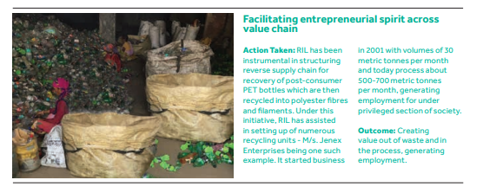

**Future prospects**

Reliance Industries Ltd (RIL) aims to double sales in about seven years, even as the company explores ways to boost profitability of its mainstay refinery and chemicals businesses.

RIL wants to venture into e-commerce, healthcare, education and agriculture in the next two years.

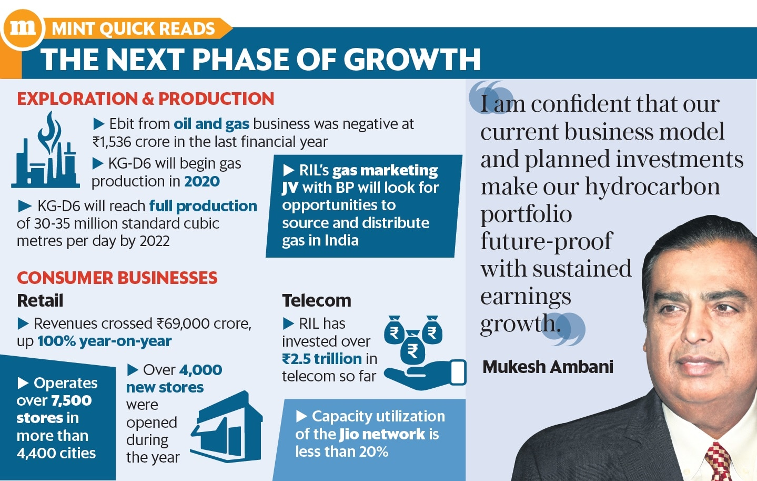

## Expenditure on CSR Initiatives

The following table presents theme-wise CSR expenditure of Reliance for the year 2017-18.

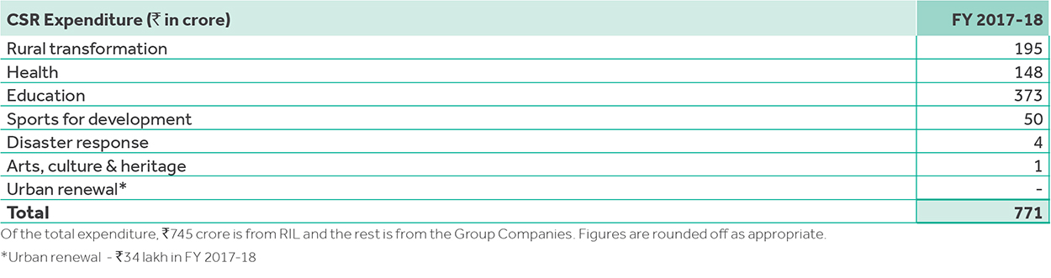

## Rural Transformation

* Livelihoods of 1.2 million+ farmers, fisherfolk and livestock owners enhanced (over 4.8 million since inception)
* Eco-consistent soil conservation resulted in bringing more than 7,000 Ha of land under sustainable agricultural practices (over 64,000 Ha since inception)
* Water harvesting and conservation efforts resulted in bringing over 32,000 hectares of land under irrigation since inception
* More than 73 billion litres of water harvesting capacity has been created since inception. As a result, 307 villages were made water secure
* Over 7 million saplings were planted this year to promote biodiversity (over 20 million since inception)

**Any Merger/ Acquisition Undertaken**

1. Airhop Communications

One of the major investments of RIL was in Airhop Communications which provides digital solutions in the field of Self-Organizing Networks(SON). The company helped power Reliance Jio’s JioSON via its eSON360 technology. This helped Jio automate its services and implement self-healing technologies for its towers. RIL acquired a stake in the company worth USD 500000 in 2015.

1. Saavn

RIL announced a strategic transaction to combine Saavn with JioMusic. The merger pegged the value of the combined entity at USD 1 billion, thereby, implying the value of the in-house company - JioMusic at USD 670 million. The OTT player is pivotal to Jio’s foray and further expansion in the sector owing to the burgeoning demand arising out of more OTT consumption by Indian audiences.

1. Eros International PLC

To further strengthen content on its suite of Jio apps, RIL acquired 5% equity stake in NYSE listed Eros International PLC at a price of USD15 per share. In addition to this, RIL and Eros International PLC announced that the two entities will equally invest upto Rs. 1,000 crores to co-produce content.

1. ALTBalaji

To further consolidate its position in the arena of content creation, RIL acquired a stake of 24.92% in ALTBalaji, a binge watching video-content platform. The platform produces video-content specifically for its online platform.

1. Edcast

In 2017, RIL invested Rs 5 crores in Edcast which is an AI-powered knowledge cloud for personalized learning. This investment was aimed at attracting new audiences in the Indian online education sphere

**References**

<https://www.wikipedia.org/>

<https://www.reliancepetroleum.com/>

<http://www.reliance.in/>

[https://telecom.economictimes.indiatimes.com/](https://telecom.economictimes.indiatimes.com/slide-shows/everything-to-know-about-companies-acquired-by-ril-to-complement-jios-operations/64599666)

[https://www.livemint.com/Companies/](https://www.livemint.com/Companies/ZXkH1gEUb15hQDUzgm9F3I/RIL-AGM-Mukesh-Ambani-wants-to-double-Reliance-Industries.html)

<https://economictimes.indiatimes.com/markets/stocks/news/>